**Guide for Parents in using online resources**

Your children have access to a range of online resources in school and most of these are also available at home.

Below is a guide for parents to assist their children in accessing these resources.

**Google Classroom**

For the older pupils links to the resources can be found via their google classroom.

**IMPORTANT**

**To access Google Classroom, pupils need to be logged in to their google account (name@padrepioprimary.co.uk)**

Make sure you have logged in to your child’s google account

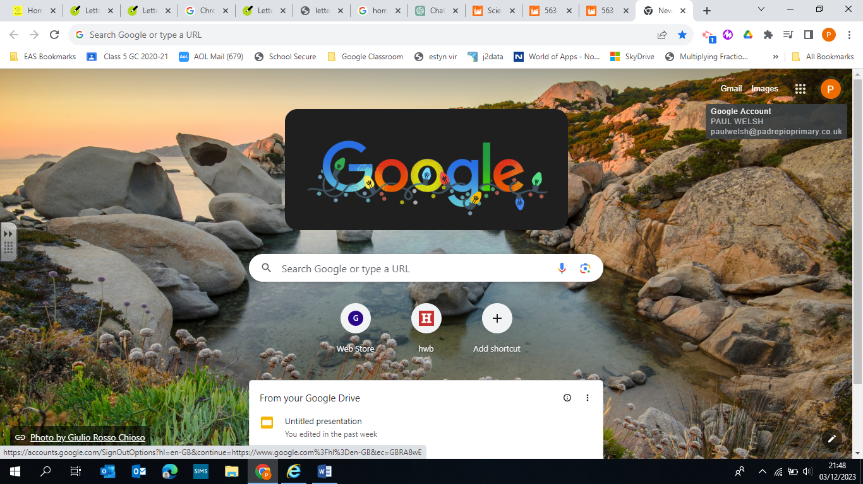

**Alternatively all the links can be found on the school website:** [**https://www.padrepiorcprimary.co.uk/**](https://www.padrepiorcprimary.co.uk/%20%20)  **: Pupils Tab / Our Virtual School**

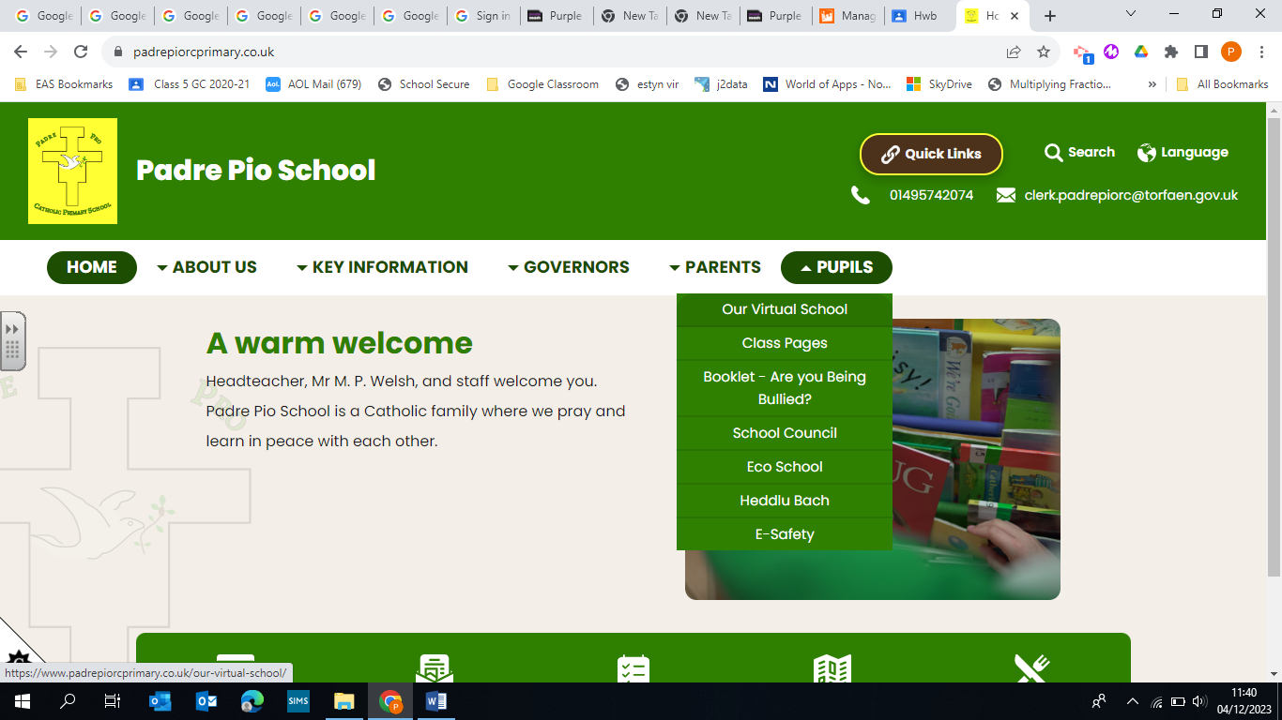

**Online resources available**

|  |  |  |
| --- | --- | --- |
| **School Website** | [**https://www.padrepiorcprimary.co.uk**](https://www.padrepiorcprimary.co.uk)  Click on the Pupils Tab and then Our Virtual School to find links to the resources below**.** | **C:\Users\ppp.pwelsh\AppData\Local\Microsoft\Windows\INetCache\Content.MSO\BB0C323F.tmp** |
| **Hwb** | [**https://hwb.gov.wales/**](https://hwb.gov.wales/)  **A digital platform provided by Welsh Government. All resources are free to access**    **eg Britannica Education -** the information in Britannica School is aligned to the curriculum, updated daily and hosts thousands of educational articles as well as images, videos, eBooks. The information is safe and reliable for primary aged children  **Just 2 Easy:** A range of tools, apps and games, for Maths, English, Computing and cross curricular activities. | **C:\Users\ppp.pwelsh\AppData\Local\Microsoft\Windows\INetCache\Content.MSO\447E7CF1.tmp** |
| **Purple Mash** | [**https://www.purplemash.com/#tab/home**](https://www.purplemash.com/#tab/home)  A cross curricular website, enabling children to explore and enhance their knowledge in a fun and creative way. Hosted online and compatible with all tablets and computers, it delivers an exciting mash-up of curriculum focused activities, creative tools, programs and games. | **C:\Users\ppp.pwelsh\AppData\Local\Microsoft\Windows\INetCache\Content.MSO\83FD35A5.tmp** |
| **Education City** | [**https://go.educationcity.com/**](https://go.educationcity.com/)  Education City is an online learning resource used in over 15,500 schools in the UK and worldwide.  All children  have access to curriculum-based, interactive, fun activities that they can work through by themselves or with adult support. | **C:\Users\ppp.pwelsh\AppData\Local\Microsoft\Windows\INetCache\Content.MSO\B0A11BFB.tmp** |