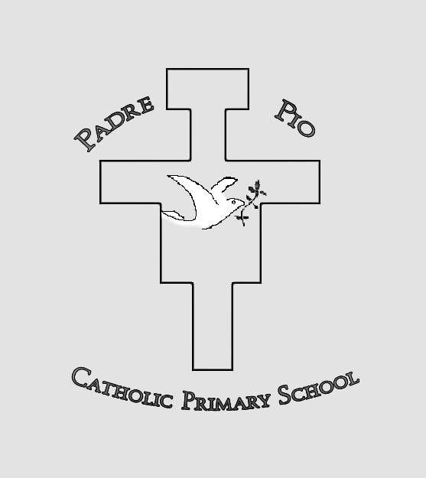
PADRE PIO CATHOLIC PRIMARY SCHOOL
Conway Road, Pontypool, Torfaen, NP4 6HL

Padre Pio is a Catholic family where we pray and learn in peace with each other.
Together we take the message of Jesus to the world.

APPLICATION FORM

THIS SECTION TO BE COMPLETED BY SCHOOL
Date application received
Birth certificate | Yes / No
Baptismal certificate | Yes / No
Letter of support from Priest/Faith Leader | Yes / No
Proof of residence | Yes / No
SEN statement | Yes / No

Please complete all sections of the application form

SECTION 1 – Family Details

Child’s Full Name (Block capitals): …………………………………………………….. Gender: ………….

Names of parent(s) / Legal Guardians(s)
Mr and Mrs/Mr/Mrs/Miss/Ms (delete as applicable)
(A) Parents’/Guardians’ Names & Address: (B) Father/Mother’s Name & Address (if different from A):

………………………………………………. ………………………………………………

………………………………………………. ………………………………………………

Please indicate the child’s weekday home address (A or B): ………..
If the child resides at both addresses, please indicate how many school days are spent at each address:

…………………………………………………………………………………………………………….

(You must provide proof of address)

Contact telephone number: ………………………………. Email address: …………………………………….

SECTION 2 – Information Relating to the Child

Date of birth: …. / …. / ……….

(You must provide a copy of the birth certificate)

Is the child baptised? Yes / No

Date and place of baptism ……………………………………………………………………………………………..

(You must provide a copy of the baptism certificate)

Denomination (please select):

Catholic Another Christian denomination Non-Christian

Please specify ……………………. Please specify …………..............

Current nursery or primary school attended: …………………………………………………………………..........

Does the child have a sibling on roll at this school in September? Yes / No

If Yes, give name of sibling and year group: …………………………………………………………………………

Is the child a looked-after or previously looked-after child, i.e. in the care of Social Services? Yes / No
(If Yes, you must provide details of the local authority / Social Worker)

Does the child have a written Statement of Additional Learning Needs or an Individual Development Plan (IDP) which names a school?
Yes / No
If Yes, which school is named? ………………………………………………………………………………………..
(You must provide a copy of the ALN Statement or IDP.)

The following MUST be included with the application form:
* Copy of birth certificate
* Proof of permanent address
* Copy of baptismal certificate – if applicable
* Priest / faith leader letter of support - if applicable
* ALN Statement or IDP – if applicable

DECLARATION
I hereby declare that the information given by me on this form is accurate and complete to the best of my knowledge and I will inform you of any alteration to the particulars given.

Signature of Parent/Guardian: …….….…………………………………………. Date: …………………

Please print name (in capitals): ………………………………………………….

Please do not hesitate to contact school if you need any assistance in completing this form.
Once completed please return this form directly to Padre Pio Catholic Primary School marked for the attention of the Clerk to the Admissions Committee. The school will acknowledge receipt of the application form by email and/or phone.
Please note that completion of the application form does not guarantee the allocation of a place.

Our aim is to provide a high-quality Christian Education based on the teachings of Christ in the Gospels, where each individual is a valued member of our community and is able to develop his or her talent to the full. We aim to promote in all members of our community, faith, and religious commitment, in accordance with the rites, practices and teachings of the Catholic Church.

